Unidad académica/organismo que lo desarrolla: | Departamento de Teoría de las Artes Facultad de Artes
Horas de trabajo presencial y no presencial:
Wednesday china hour 21.000

Santiago los Miercoles 9. 00 horas

Every first Wednesday of the month you will be on zoom with the teacher. During the month I will send videos and Power Points with information

Número de Créditos SCT - Chile | X créditos.

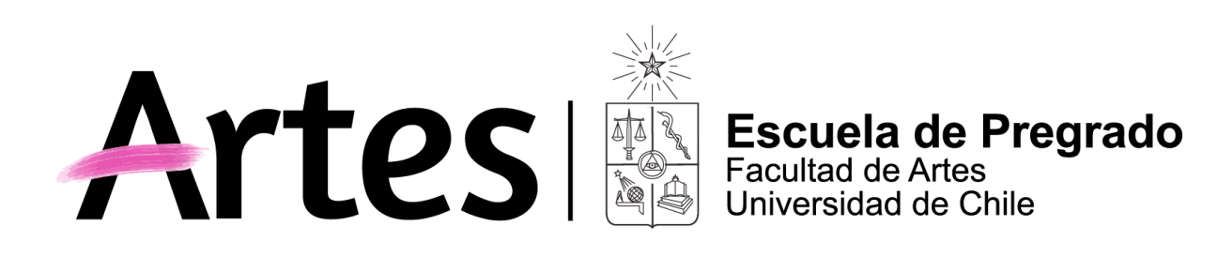
NOMBRE ACTIVIDAD CURRICULAR
History of Arte: Chilean Heritage online

Historia de Chile: Patrimonio chileno ONLINE

Propósito General del Curso
What’s it all about it:
This curse it is for international students who likes to study a semester in the Universidad de Chile. They will learn about our culture beg round and our heritage.
Starting with the pre-Columbian time and the Colonial time in South America
We will speaker about Chilean heritage: art, literature, music from yesterday to today.

Competencias y Subcompetencias a las que contribuye el curso
Objectives of this course:
The most important objective is to give to the international student information about Chilean Heritage starting with the wonderful world of the Pre-Columbian art, Incas and the arrival of the spanish people our colonial time. The lights of art during different parts of the chilean history., the biggest interpretation we had in art, literature, music, cinema, theater. Us heritage is tangible or intangible we have a lot to took
We will see the problems of heritage today in Chile what are similar to other parts of the world. The world is changing concepts are getting different and we see where is Chile in this new system in clime change, traffic of art, fake art and so one.

Resultados de Aprendizaje
End of clases
The students will get a lot of information about pre-Columbian arte us we say Chile before Chile, Colonial time, Independencies from Spain and slowly they learn about chilean heritage getting to the lust century and art today so the students will know at the end of the semester a lot of the different cultural indicatives.

Saberes/Contenidos
What are the course speaking about?
First we will speak about Heritage what is heritage what problems we have today, Heritage in museum outdoor where ever it is.
We will speak about the Pre-Columbian time. The deferent Indians peoples we had in this long country cold Chile and their cultural systems how they life and believe, shaman and the Altiplano
Going true colonial time, costumes, music and daily live, a little bit of history, the city of Santiago and the mapuches.
The independency of Chile from Spain and the time after a long time …hearing the music of Isidora Zegers, and learning how we live in Santiago. Lot of scientific investigation is going one, first University. We get the visit of very good painters Mulato Gil first the Rugenda, Gay and other artistic who let us fanatic pictures about the live in Chile. Then we jump to the artistic who went to study in Paris XIX and XX painters like Pedro Lira. In folklore I will speak about Quasimodo, la Tirana, baile chino UNESCO Heritage I will not forget Pablo Neruda, Gabriela Mistral, Víctor Jara, Violeta Parra. Los Jaivas…..

Metodología
Methodology
Classes on line with power points, music. inviting other specialists in chilean heritage it will by a dynamic course

Evaluación
Notes;
I will ask for two investigations about important things we will speak in classes. It will be elected between the teacher and the student so the personal inters of the students will be important. You will present the investigation in the class on line also you send the investigation to the teacher’s mail.

Requisitos de Aprobación
You past the course when:
You must come to more than 80% of the classes on line and get notes better the 4.0 (Here in Chile the nots go from 1.0 very bed to 7,0 very good)

Palabras Clave

History of Arte: Chile culture and heritage give you an opportunity to see, hear and learn about our heritage

Bibliografía Obligatoria | Bibliografía Complementaria
Visit the Little history of Chile Sergio Villalobos  Oyendo a Chile S Claro  Biography I will be given in classes  Articles Articles and papers I will send to the student  t videos Power Points I wills end to the students  Videos  And  M  Oyendo  L | I

